SIMATS Engineering
Name: G. Rajasekhar Reddy Date:21/07/2026
Reg No:192424216
Course Name: Query Processing for Data Science
Course Code:DSA0502 Lab Programs

1.Write a Pandas program to select the distinct department id from employee’s file.
Aim:
To write a Pandas program to select the distinct department IDs from the employee’s file.
Program:
import pandas as pd

employees = pd.read_csv("employees.csv")

distinct_dept = employees["department_id"].drop_duplicates()

print("Distinct Department IDs:")
print(distinct_dept)
Output:
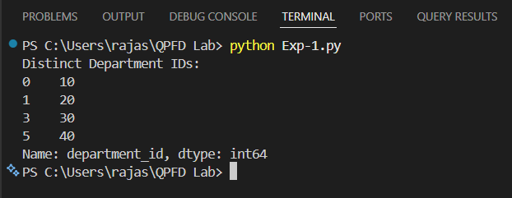
Result:
The program successfully selected and displayed the distinct department IDs from the employees file.

2. Write a Pandas program to display the IDs of employees who have done two or more
Aim:
To write a Pandas program to display the IDs of employees who have done two or more jobs.
Program:
import pandas as pd

jobs = pd.read_csv("employee_jobs.csv")

job_count = jobs.groupby("employee_id").size()

result = job_count[job_count >= 2]

print(result)
Output:
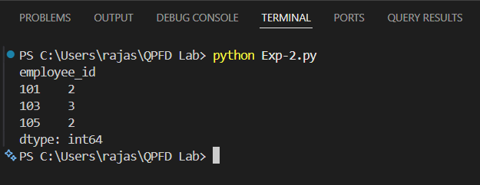

Result:
The program successfully displayed the IDs of employees who have done two or more jobs.

3.Write a Pandas program to display the details of jobs in descending sequence on job title.
Aim:
To write a Pandas program to display the details of jobs in descending order based on the job title.
Program:
import pandas as pd

jobs = pd.read_csv("jobs.csv")

result = jobs.sort_values(by="job_title", ascending=False)

print(result)
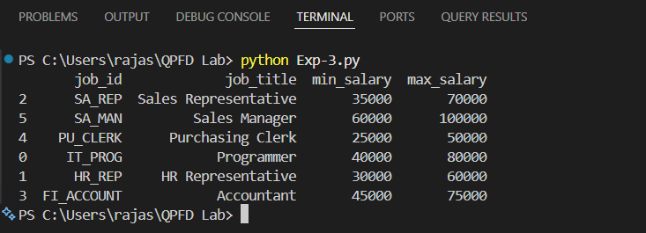
Output:
Result:
The program successfully displayed the job details in descending order based on the job_title column.

4.Write a Pandas program to create a line plot of the historical stock prices of Alphabet Inc. between two specific dates.
Aim:
To write a Pandas program to create a line plot of the historical stock prices of Alphabet Inc. between two specific dates.
Program:
import pandas as pd
import matplotlib.pyplot as plt

data = pd.read_csv("alphabet_stock.csv")

data["Date"] = pd.to_datetime(data["Date"])

filtered = data[(data["Date"] >= "2024-01-02") & (data["Date"] <= "2024-01-06")]

plt.plot(filtered["Date"], filtered["Close"], marker="o")
plt.title("Alphabet Inc. Stock Prices")
plt.xlabel("Date")
plt.ylabel("Closing Price")
plt.grid(True)
plt.show()

Output:
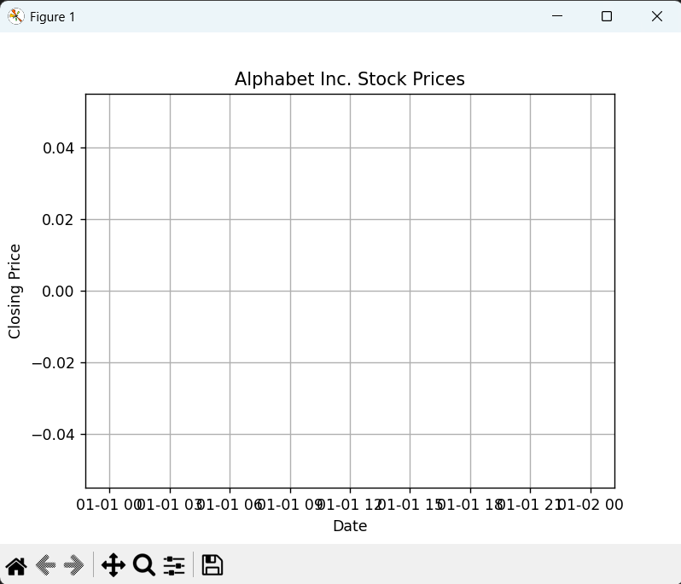
Result:
The program successfully created a line plot of Alphabet Inc.'s historical stock prices between the specified dates.

5.Write a Pandas program to create a bar plot of the trading volume of Alphabet Inc. stock between two specific dates.
Aim:
To write a Pandas program to create a bar plot of the trading volume of Alphabet Inc. stock between two specific dates.
Program:
import pandas as pd
import matplotlib.pyplot as plt

data = pd.read_csv("alphabet_stock.csv")

data["Date"] = pd.to_datetime(data["Date"])

filtered = data[(data["Date"] >= "2024-01-02") & (data["Date"] <= "2024-01-06")]

plt.bar(filtered["Date"], filtered["Volume"])
plt.title("Alphabet Inc. Trading Volume")
plt.xlabel("Date")
plt.ylabel("Trading Volume")
plt.xticks(rotation=45)
plt.show()
Output:
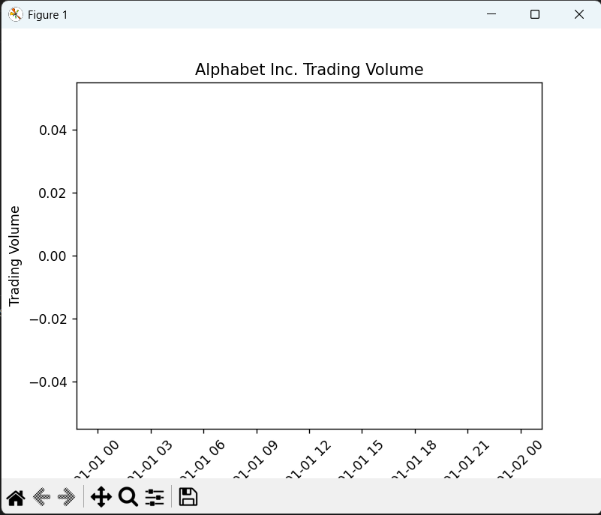
Result:
The program successfully created a bar plot of the trading volume of Alphabet Inc. stock between the specified dates.

6.Write a Pandas program to create a scatter plot of the trading volume/stock prices of Alphabet Inc. stock between two specific dates.
Aim:
To write a Pandas program to create a scatter plot of the trading volume and stock prices of Alphabet Inc. stock between two specific dates.
Program:
import pandas as pd
import matplotlib.pyplot as plt

data = pd.read_csv("alphabet_stock.csv")

data["Date"] = pd.to_datetime(data["Date"])

filtered = data[(data["Date"] >= "2024-01-02") & (data["Date"] <= "2024-01-06")]

plt.scatter(filtered["Volume"], filtered["Close"])
plt.title("Alphabet Inc. Stock Price vs Trading Volume")
plt.xlabel("Trading Volume")
plt.ylabel("Stock Price")
plt.show()

Output:
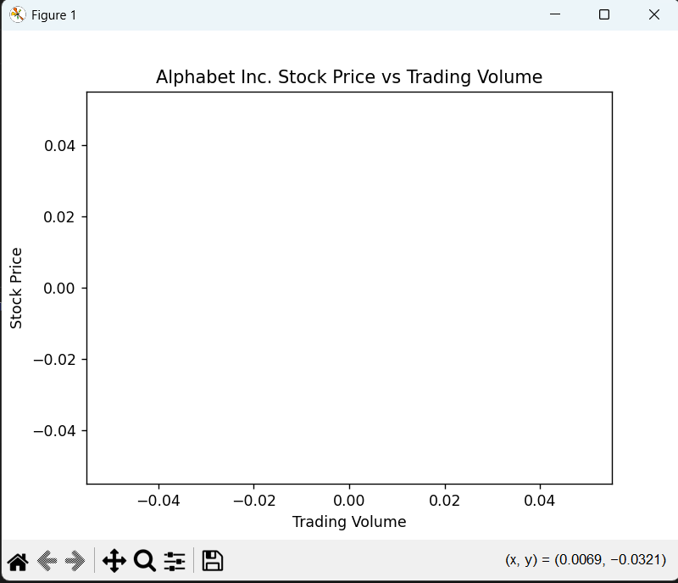
Result:
The program successfully created a scatter plot of the trading volume and stock prices of Alphabet Inc. stock between the specified dates.

